**Angular 6 vs Ionic 4 LifeCycle**

**Angular**

1. **lifecycle step**

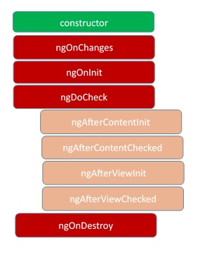

**goToSecondPage(){**

**this.router.navigate(['second',{id:"am"}]);**

**}**

**ngOnDestroy(){**

**console.log("SecondComponent ngOnDestroy");**

**}**

**GotoBack(){**

**this.location.back();**

**}**

**2. constructor() call each time**

**3. When negative route**

**constructor(location: PlatformLocation) {**

**location.onPopState(() => {**

**console.log('pressed back!');**

**});**

**}**

**4.Store Route History in Rest.service and use This Veriable all Place As Needed**

**import { Router,Route,NavigationStart} from '@angular/router'**

**...**

**this.router.events.subscribe(**

**event=>{**

**let evt1:any=event;**

**console.log("event",event);**

**if(event instanceof NavigationStart) {**

**this.rest.appDirectry=evt1.url;**

**console.log("eventsurl" ,this.rest.appDirectry);**

**}**

**}**

**);**

**Ionic**

**1.Push a page**

**this.router.navigate(['page1',{id:"am"}]);**

**Inter the Page call this**

**ionViewWillEnter(){**

**console.log(" home.page.html ionViewWillEnter()");**

**}**

**constructor(public router:Router){);**

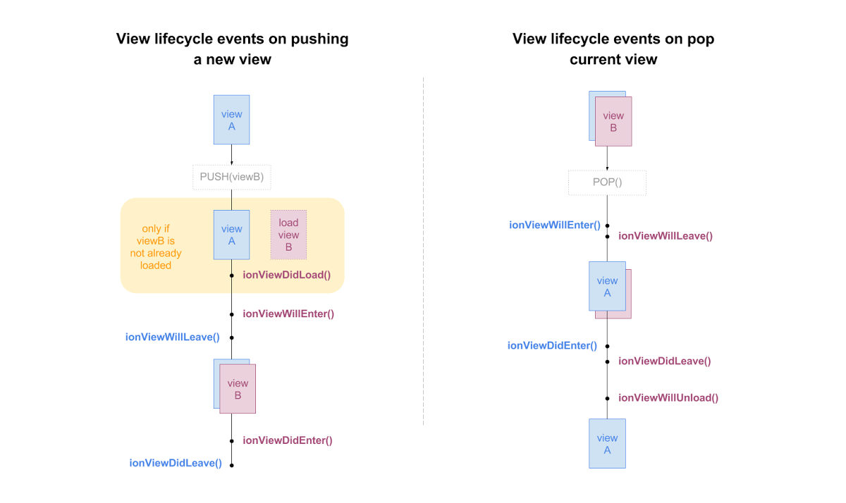

**On Destroy**

**this.navCtr.pop();**

**2. constructor() not call each time but ionViewWillEnter() call each time when come back or first visit**

**3. When negative route**

**ionViewWillEnter(){**

**console.log(" home.page.html ionViewWillEnter()");**

**}**

**4.Store Route History in Rest.service and use This Variable all Place As Needed**

**import { Router,Route,NavigationStart} from '@angular/router'**

**...**

**this.router.events.subscribe(**

**event=>{**

**let evt1:any=event;**

**console.log("event",event);**

**if(event instanceof NavigationStart) {**

**this.rest.appDirectry=evt1.url;**

**console.log("eventsurl" ,this.rest.appDirectry);**

**}**

**}**

**);**